“Do not be anxious about anything, but in everything, by prayer and petition, with thanksgiving, present your requests to God.”
-- Philippians 4:6

- Remember to pray! ☺
- Answer each question in the space provided (use separate paper for scratch work).
- All relevant work must be shown for full credit.
- Copying work from another source is plagiarism and carries serious penalties.
- Calculators are permitted, but no notes, text, or laptops. Cell phones should be muted and left in your pocket or bag.

Simplify (exact answers):
- 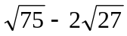 [2]
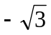
- (-2x²)³ ÷ (-4x⁻²) [2]
2x⁸
- 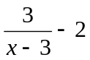 [2]
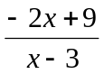
- 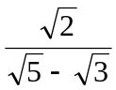 [2]
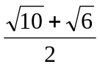
- 1 – x^{2 ln(1)} [2]
0
Solve:
- 4x² = 18x [2]
x = 0 or 9/2
- y⁴ + 7y² – 18 = 0 [4]
y = 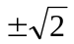
- 2z² + 3z = 2 [3]
z = ½ or -2
- | 2x – 5 | < 11 [4]
-3 < x < 8
- log₁₀( 100(2^{x}) ) = 2x [4]
(give exact answer)
x = 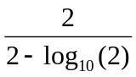

Word Problems:
- Together, a house and a lot cost $480,000. The house costs seven times as much as the lot. How much did the house cost? [3]
$420,000
- Find the equation of a line passing through (0,-1) and perpendicular to the line
3x - 6y + 5 = 0. [4]
y = -2x-1
- The supply and demand functions for soybeans are given as:
Supply function: P = 1.2 Q_{s} + 0.6
Demand function: P = -2.0 Q_{d} + 10.2
Find the equilibrium point. [4]
Q = 3, P = $4.20
- You decide to set up a small business selling coffee to students on campus. It costs $500 for start up, and a further 80 cents per cup in operating costs. You are able to sell each cup of coffee for $1.20.
  - Assuming a linear cost function, what is your cost function? [1]
C(x) = $500 + $0.80 x
  - How many cups of coffee do you need to sell to break even? [3]
1250
- A book is priced at $92. You are given a discount of 20%. GST+PST are charged at 14%. What do you finally pay for the book? [3]
$83.904
- There are 44 students in a class with boys and girls in the ratio 4:7. Four more girls join the class. What is the new ratio of boys to girls? [3]
1:2
- A company produces two models of automobile cold-air intakes, model A and model B. To produce each model A requires 3 lb of aluminum and 6 min of labour. To produce each model B requires 4 lb of aluminum and 3 min of labour. A total of 1000 lb of aluminum and 20 labour-hours are available for the production of cold-air intakes each day.
  - Sketch a graph, shading the region representing the allowable number of models A and B the company can produce each day. [8]
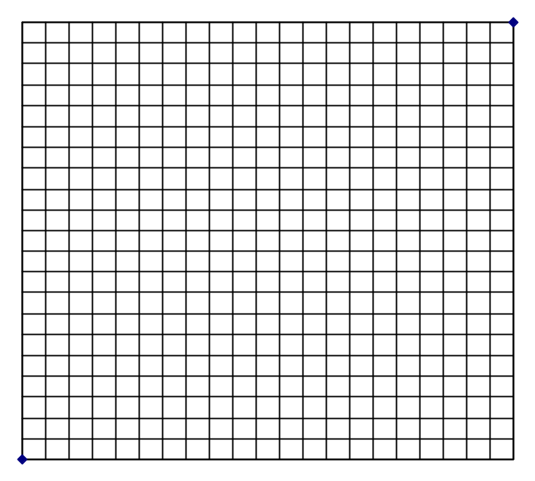
  - The profit for each model A intake is $2.00, and the profit for each model B intake is $1.50. How many intakes of each model should the company produce each day in order to maximize profit? [3]
A = 120, B = 160, profit = $480
- The 3rd term of a geometric progression is 6, and the 7th term is 96. Find the first term and the second term. [4]
t₁ = 3/2, t₂ = 3
- Consider the series 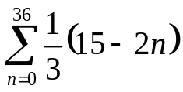.
  - What is the first term of the series? [1]
5
  - What is the last term of the series? [2]
-19
  - What is the sum of the series? [2]
-259
- A ball is released at a height of 320 cm and bounces off the floor below. Each bounce is 3/4 of the height of the previous bounce.
  - How high is the 3rd bounce? [2]
135cm
  - How far does the ball travel (up and down) before it stops? [5]
2240cm
- Find the centre and radius of the circle x² + y² – 8y – 9 = 0. [3]
centre (0,4), radius 5
- The revenue for a charter flight depends on the number of unsold seats. If the revenue is given by R(x) = 2200 + 30x – x², where x is the number of unsold seats, find the maximum revenue, and the number of unsold seats that corresponds to this revenue. [5]
x = 15 unsold seats; revenue = $2425
- A debt of $900 due a month ago is to be paid back in 2 equal payments, one due 3 months from now and another, 8 months from now. Find the equal payments if simple interest is charged at 18% p.a. (Choose any focal date.) [6]
focal date @-1mo: $493.30
focal date @now: $439.84
focal date @+8mo: $492.29

- Elma took out a mortgage for $200,000 to buy a house. She repaid this by fixed amounts at the end of each month for 20 years. Find her monthly payments if the interest rate is 6% p.a. compounded monthly. [8]
$1432.86
- y varies with the square of x, and z is inversely proportional to y. When x is 2, z is 6. What is the value of z when x is 3? [4]
8/3
- Each layer of glass reduces the light passing through it by 20%. How much light would pass through 6 layers of glass? [4]
26.21%
- How long will it take an investment of $2,000 to grow to $5,000, at an interest rate of 12.5% p.a. compounded continuously? [5]
7.33yrs

